Exercise 4-3 The study of adversarial loss of GANs

Jirayu Petchhan, D10907801

Loss selection for training GAN

There are 4 losses for selecting i.e., non-saturated, saturated, WGAN, and WGAN-GP.

And we keep the hyper-parameter setting as default

We will study in the term of changing losses how its effect learning of GAN.

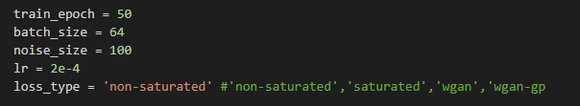

For **non-saturated loss**

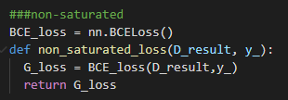

Output generated images from each epoch

|  |  |
| --- | --- |
| epoch | Output images |
| 1 |  |
| 25 |  |
| 50 |  |

Training result

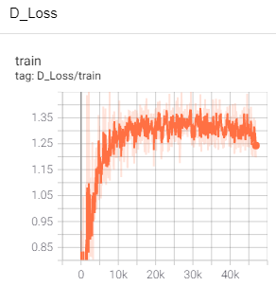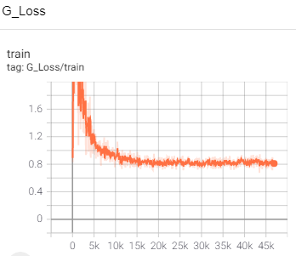

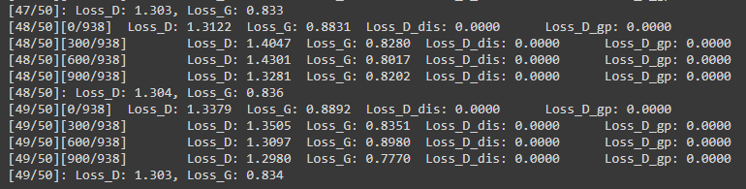

For **saturated loss**

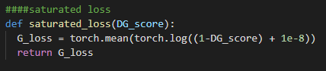

Output generated images from each epoch

|  |  |
| --- | --- |
| epoch | Output images |
| 1 |  |
| 25 |  |
| 50 |  |

Training result

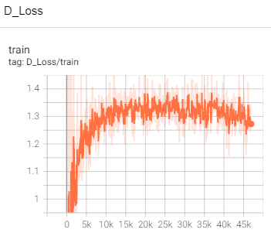

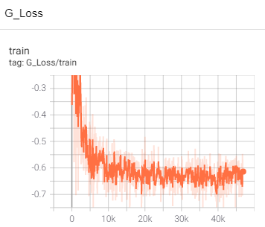

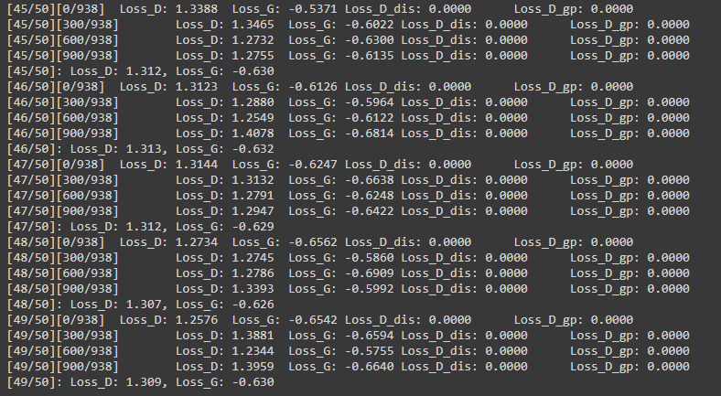

For **WGAN loss**

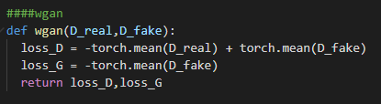

Output generated images from each epoch

|  |  |
| --- | --- |
| epoch | Output images |
| 1 | C:\Users\e_user\Downloads\wgan\ep0_op.png |
| 25 | C:\Users\e_user\Downloads\wgan\ep24_op.png |
| 50 | C:\Users\e_user\Downloads\wgan\ep49_op.png |

Training result

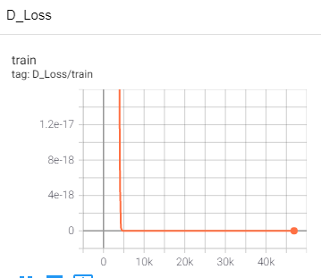

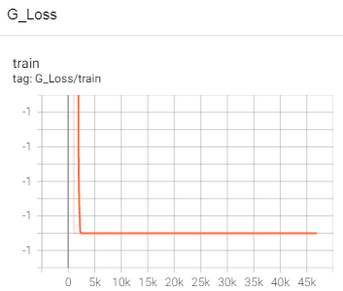

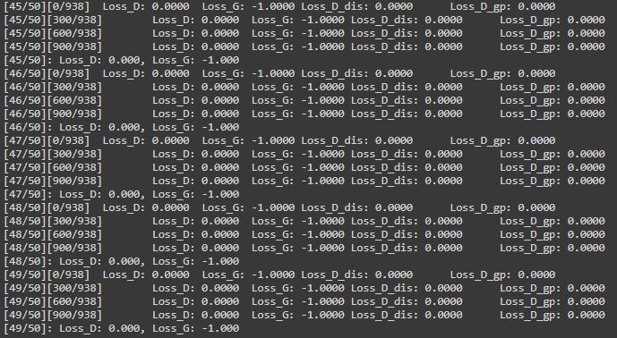

For **WGAN-GP loss (GP = gradient penalty term added)**

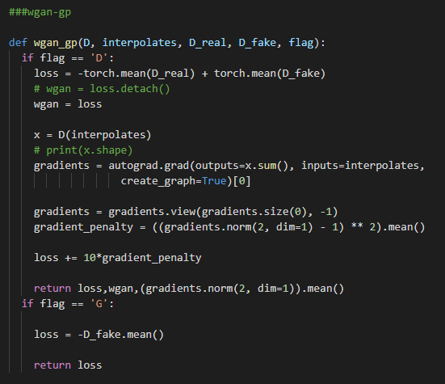

Output generated images from each epoch

|  |  |
| --- | --- |
| epoch | Output images |
| 1 |  |
| 25 |  |
| 50 |  |

Training result

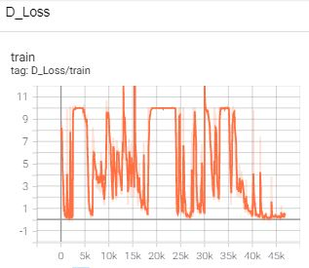

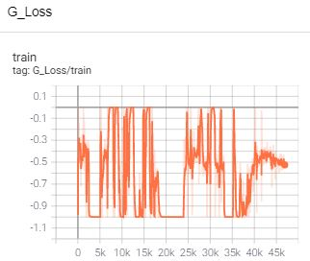

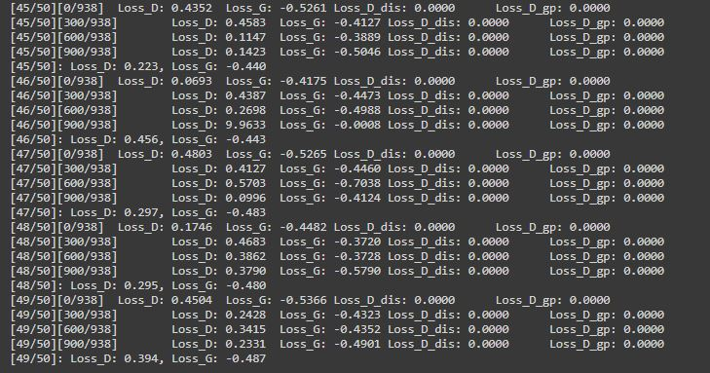

**Conclusion**

The result from testing with the criterion of non-saturated, saturated, wgan, wgan-gp loss selection, we get the best optimization when testing with saturated loss (the loss is so smooth and much better from optimization process). In the part of wgan and wgan-gp, even though there are gradient penalty and critic term the results don’t look smoothly. The learning process that affects to optimize too oscillated in loss both discriminator and generator.